## Discrete Mathematics

Background

This topic deals with fundamentals of discrete mathematics (counting, relations, functions and partially ordered sets).

* **Mathematical Logic**

Prove identities/equalities/inequalities by induction

* **Counting**

multiplication principle, sumrule and the five basic formulas

pigeonhole principle

* **Relations and Digraphs**

Directed graphs, matrix of finite relation

Properties of relations on a set of pairs (reflexivity, irreflexivity,

symmetry, asymmetry, antisymmentry, transitivity)

transitive closure of a relation.

* **Functions**

one-to-one, onto, bijective, invertible and inverses

* **Order Relations and Structures**

Partial order (set + relation)

Isomorphic (two partial orders)

**Lesson 0**

Mathematical Induction

(From COS2601)

This essentially is the same as using a recursive definition to define a language. It uses a trick which allows you to prove a statement about an arbitrary number n by first proving it is true when n is 1 and then assuming it is true for n=k and showing it is true for n=k+1.

**Proof by induction:**

|  |  |
| --- | --- |
| Recursive Definition | Clause |
| Show n=1 is true (LHS = RHS) | Basis Clause |
| substitute k into formula (LHS) | Inductive Clause |
| Substitute k+1 into formula (RHS) | Extremal clause |

Example ASS 01 Q1a

Let be the statement

**Basis Clause**

Show that

is where

.

Therefore, is true

**Inductive Hypothesis**

Show that.

is where

Assume

**Extremal Clause**

If is true, then must also be true

Assume

But,

Therefore, by the induction hypothesis:

Thus, is true

Hence, is true

It then follows by mathematical induction that is true.

Example ASS 01 Q1a

Let be the statement

**Basis Clause**

Show that

is where

and

Therefore, is true

**Inductive Hypothesis**

Show that

is where

Assume

**Inductive Step**

If is true, then must also be true

Assume

But,

Therefore, by the induction hypothesis:

Re-write 4 as 3+1

Multiplying out

By regrouping

Remove from both sides

is true for all

Thus, is true

Hence, is true

It then follows by mathematical induction that is true for

Example

TODO: example with induction to prove divisibility

**Example:**

Prove by induction that for

Let be the statement

**Basis Clause**

*If you have a restriction use that, otherwise use*

Let

LHS:

RHS:

Therefore, the statement is true for

**Inductive Clause**

Assume . Assume is true   
Therefore, we assume that

**Extremal Clause**

We need to show that is true

LHS:

RHS:

Therefore:

by the induction hypothesis

Therefore, is true, and from the principal of mathematical induction it follows that is true for

**Example:**

Prove by induction that is a multiple of 3 for

**Basis Clause**

Let

LHS:

LHS is a multiple of 3, the statement is true for

**Inductive Clause**

Assume that is true for some

Therefore, we assume that is a multiple of 3

**Extremal Clause**

Assuming that is true, show that is true

LHS:

Perfect cube formula

But is a multiple of 3 and is also a multiple of 3

Therefore, is true, and from the principal of mathematical induction it follows that, is a multiple of 3

**Example: NOV 2016 Q1**

Prove by induction that for

**Basis Clause**

Inductive Clause

Extremal Clause

**Example:**

Prove by induction that

Let be the statement

**Basis Clause**

Let

LHS:

RHS:

Therefore, the statement is true

**Inductive Clause**

Assume is true for some

LHS:

RHS:

Therefore, we assume

**Extremal Clause**

Assuming is true, we must show is true

LHS:

RHS:

**Example: NOV 2014 Q1**

Prove by induction that for

Let the statement be

**Basis Clause**

Let

LHS:

RHS:

Therefore, is true

**Induction Clause**

Assume is true, for some

Therefore, we assume that

**Extremal Clause**

Assuming is true, we must prove

LHS:

RHS:

LHS:

By the induction hypothesis is true

Therefore, by mathematical induction

**Example: NOV 2011 Q1**

Prove by induction that is a multiple of 3 for

**Basis Clause**

Let

LHS:

LHS is a multiple of 3, therefore the statement is true for

**Inductive Clause**

Assume for some

Therefore assume is a multiple of 3

**Extremal Clause**

Assuming , we must show that is true

LHS:

By the induction hypothesis, is divisible by 3

Also, is divisible by 3

The constant 3 is also divisible by 3

Therefore, is true, and from the principal of mathematical induction if follows that by 3.

**Lesson 1**

Counting

Being able to count the number of ways something can happen.

**Product Rule (AND)**

* Procedure can be broken down into a sequence of tasks
* Number of outcomes of each task is
* different ways to perform a procedure

Example: If I have 4 different t-shirts and 3 different pairs of shorts, how many outfits do I have?

**Sum Rule (OR)**

* If a task can be performed in one of or ways, then there are ways to perform the task.

Example: I want to take a trip to the beach. I can travel to one of 37 international beaches or one of 14 domestic beaches. How many beach destination choices do I have?

**Tree diagram**

* A visual strategy we can use to represent counting problems
* This is good if you are focused on a particular outcome

Example: If I have 4 different t-shirts and 3 different pairs of shorts, how many outfits do I have?

s1 t1s1

t1 s2 t1s2

s3 t1s3

s1

t1 s2

s3

s1

t1 s2

s3

s1

t1 s2

s3

**Subtraction Rule (Inclusion exclusion)**

* If a task can be done in either one of or ways, then the total number of ways to do the task is minus the number of ways that are common

Example: how many bitstrings of length 7 either start with 1 bit or end with 3 bits 000?

Number that start [1][ ][ ][ ][ ][ ][ ]

with 1

Number that end [ ][ ][ ][ ][0][0][0]

with 000

Number that start with 1 [1][ ][ ][ ][0][0][0]

and end in 000

**Division Rule**

* There are is ways to do a task if it can be done using a procedure that can be carried out in ways, where the corresponding outcomes per group.

Example: how many ways can I sit 6 people around a circular table where two seats are considered the same when each person has the same left and right neighbour?

***Set one person and then the rest***

**Lesson 2**

Permutations and Combinations

**[SELECT] Permutation**:

number of elements in the set

number of elements chosen

* An ordered arrangement of unlike objects.
* An r-permutation is the arrangement of r-elements of a set

no repetition:

fixed repetition:

unlimited repetition:

Example: Let . Find all 2-permutations

Example: How many ways can 100 marathon runners place 1st, 2nd, and 3rd?

**[ARRANGE] Combination**:

number of elements in the set

number of elements chosen

* An unordered arrangement of unlike objects.
* An r-combination is a subset of the set with r-elements

Example: Let . Find all 2-combinations. Relate this to the number of 2-permutations

Example: how many poker hands of 5 cards can be dealt from a standard of 52 cards

Example: how many diagonals does a convex polygon with n sides have?

**Lesson 3**

Counting Continued

<https://app.creately.com/> - Venn Diagrams

Formulas can be applied to these five basic types:

Arrangements

* No repetition (n!)
* Fixed repetition (Apply Division Rule)
* Unlimited repetition

Combinations

* No repetition (Apply product Rule)
* Unlimited

Example: Consider numbers (strings) of length 5 over the ten digits 0,1,2,3…8,9. Suppose repetition of digits allowed.

The numbers may begin with 0

.

How many different numbers are there?

[10][10][10][10][10] *each position has 10 options (incl 0)*

1. How many of these numbers have no 0?

[9][9][9][9][9] *each position has 9 options (excl 0)*

1. A picture containing table, clock

   Description automatically generatedHow many of these numbers have at least one 0?

*compliment of*

1. How many of these numbers have exactly three 0’s

[0][0][0][9][9] *each position has 9 options (excl 0)*

Example: Arrangement, no repetition

How many ways can you arrange the letters in the word TALES?

Example: Arrangement, repetition

How many ways can you arrange the letters in the word BARBARIC?

*repetition*

*A or B*

*8 elements, Bx2, Ax2, Rx2, Ix1, Cx1*

Question 2: A group of 40 people consists of 20 women and 20 men.

How many ways are there to:

(a) arrange the entire group in a row?

*Remember that*

**Order matters**

Men and Women (20+20)

40 choices position 1

39 choices position 2

…

1 choice position 40

(b) form a row of 6 people from the men?

**Order matters**

Men (20)

20 choices position 1

19 choices position 2

…

15 choices position 6

(c) form the group into a row with all the women in front of all the men?

**Order matters**

Product Rule (AND/+)

Women (20)

20 choices position 1

1 choice position 20

Men (20)

20 choices position 1

1 choice position 20

(d) choose a man and a woman from the group?

**Order doesn’t matter**

Product Rule (AND/+)

Women (20)

20 choices position 1

Men (20)

20 choices position 1

(e) choose 6 women and 10 men from the group?

**Order doesn’t matter**

Product Rule (AND/+)

Women (20)

20 choices position 1

20 choices position 6

Men (20)

20 choices position 1

20 choices position 10

(f) choose 15 people from the group?

**Order doesn’t matter**

Product Rule (AND/+)

Men and Women (20+20)

15 choices position 1

15 choices position 15

(g) pair the women and men off?

**Order matters**

Pairs of Men and Women (20)

20 choices position 1

20 choices position 2

…

1 choice position 20

(h) form 12 pairs from the group?

**Order matters**

Pairs of Men and Women (20)

40 choices position 1

38 choices position 2

…

18 choice position 12

(i) divide the group into 3 groups (groups 1, 2, 3) of equal size?

(j) divide the group into 3 equal groups, where each group in its own has as many men as women in it?

(k) divide the groups into two groups of equal size such that group 1 contains at least 2 men?

Example: NOV 2016 Q2

2

1. How many distinguishable arrangements are there of the letters in the word FULFILLING

10 elements

6 Unique elements (FULING)

**Order doesn’t matter**

Letters (10)

Repetition: 2!3!2!

1. How many distinguishable arrangements are there of the letters in the word FULFILLING

10 elements

6 Unique elements (FULLLING)

**Order doesn’t matter**

Letters (10)

Repetition: 2!2!

1. Suppose Gauteng car number plates consist of three letters followed by three numbers. The allowable letters are the 21 consonants (i.e. all the letters of the alphabet except A, E, I, O, U) and the allowable numbers are 0, 1, 2, 3, 4, 5, 6, 7, 8, 9. Repetition of letters and numbers is allowed.
2. How many different number plates are possible?

**Order doesn’t matter**

**Repetition Allowed**

**Product Rule (AND/x)**

Letters (21):

Numbers (10):

1. How many different number plates are possible with no repetition allowed?

<https://www.youtube.com/watch?v=26-oS3hfUfw>

**Order doesn’t matter**

**Repetition NOT Allowed**

**Product Rule (AND/x)**

Letters (21):

Numbers (10):

**Lesson 4**

Pigeonhole principle

Given items and containers, if , there is at least one container with items.

Example: Twenty cards numbered 1 to 20 are placed face down on a table. Cards are selected one at a time and turned over. If two of the cards add up to 21, the player loses. Use the pigeonhole principle to show that if 11 cards are chosen then the player can never win the game. State clearly what the pigeons and the pigeonholes are.

Pair the cards according to their numbers as follows:

(1; 20) ; (2; 19) ; (3; 18) ; (4; 17) ; (5; 16) ; (6; 15) ; (7; 14) ; (8; 13) ; (9; 12) ; (10; 11) :

We note that the numbers on each pair of cards add up to 21.

Consider the pairs of cards, adding up to 21, as the pigeonholes. There are 10 pairs. Consider the 11 cards that are chosen as the pigeons. Assign each of these cards according to its number to the pair in which the number occurs. Since there are more pigeons (11) than pigeonholes (10), then at least one of the pigeonholes will have 2 pigeons, i.e. two of the chosen cards will add to 21, and the player loses the game.

**Lesson 5**

Functions

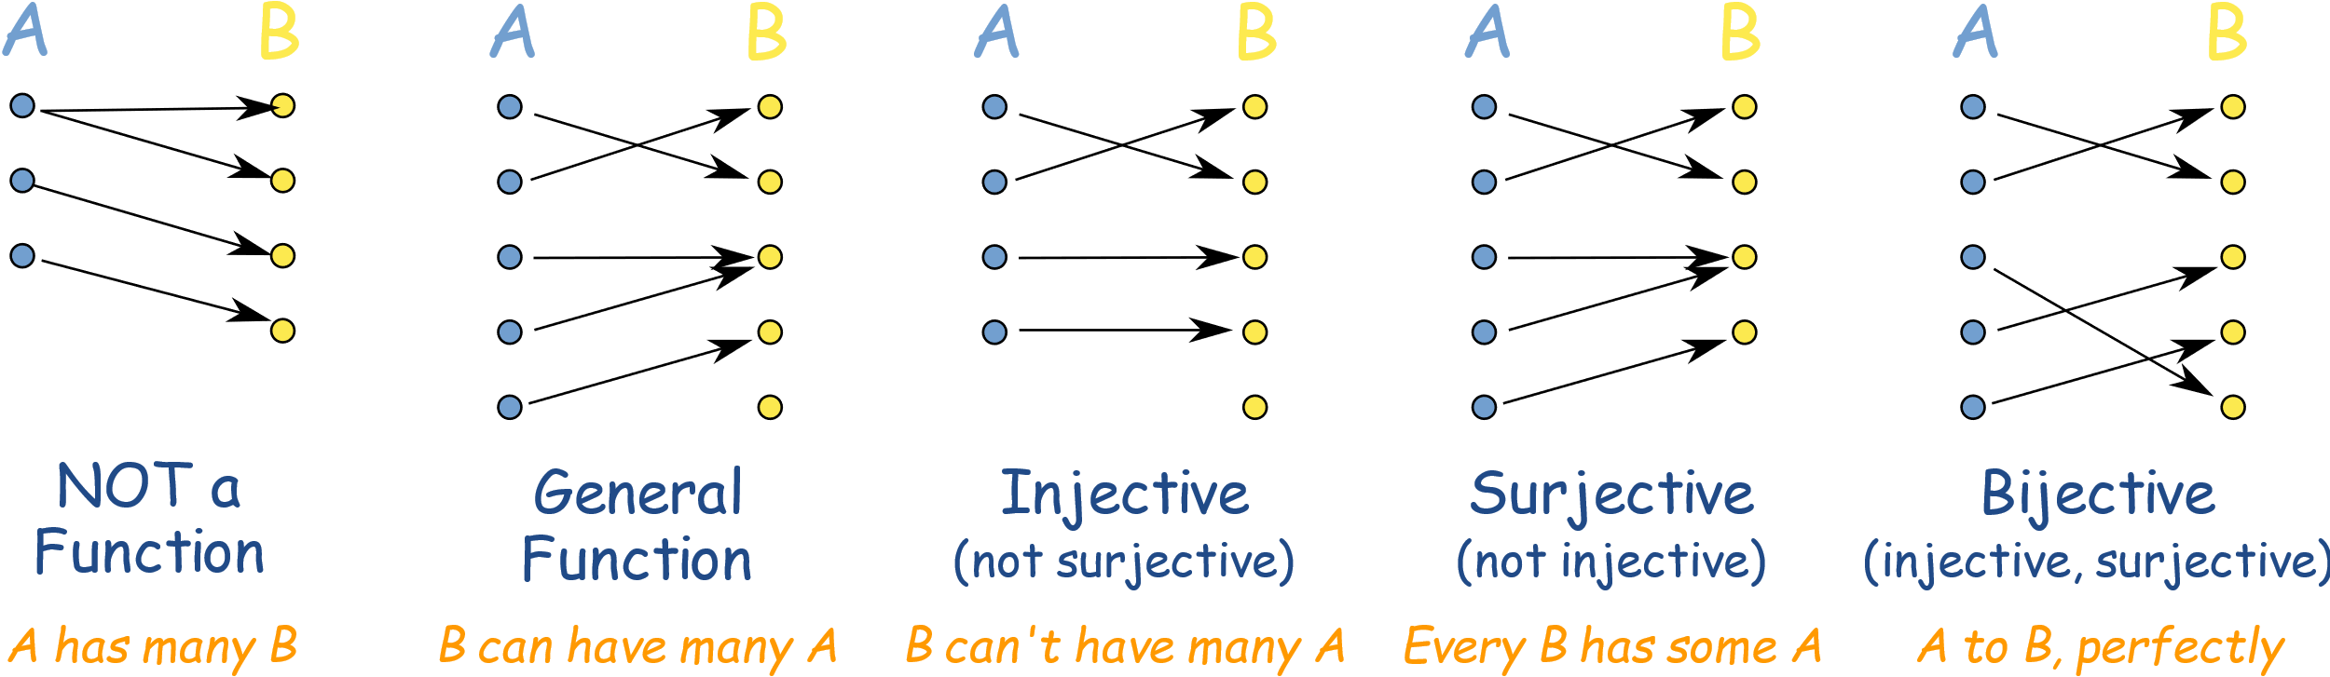

*many-to-one one-to-one one-to-one*

*correspondence*

**how to tell if a function is onto/surjective:**

The function is onto/surjective if there exists an inverse function such that the composition function equals the identity function

*Suppose that*

*Then there exists such that*

If

Let

Then

Therefore is onto/surjective

**Lesson 6**

Relations

Relations can be represented using matrices or diagraphs

Example: Let A be the set {1, 2, 3, 4}. Which ordered pairs are

in the relation R = {(a, b) | a divides b}?

1 divides everything (1,1), (1,2), (1,3), (1,4)

2 divides itself and 4 (2,2), (2,4)

3 divides itself (3,3)

4 divides itself (4,4)

So, R = {(1,1), (1,2), (1,3), (1,4), (2,2), (2,4), (3,3), (4,4)}

**Diagraphs**

1 1

2 2

3 3

4 4

**Matrices**

|  |  |  |  |  |
| --- | --- | --- | --- | --- |
|  | **1** | **2** | **3** | **4** |
| **1** | **x** | **x** | **x** | **X** |
| **2** |  | **x** |  | **x** |
| **3** |  |  | **X** |  |
| **4** |  |  |  | **x** |

Binary relation

* or is a subset of the Cartesian product

*“x is related to y”*

* The binary relation is a set of ordered pairs where and
* if

There are different ways to define binary relations.

Representing relations

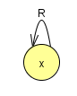

**reflexive**

if for all

*For all x,* *x is related to x (x is related to itself)*

A relation cannot be both reflexive and irreflexive

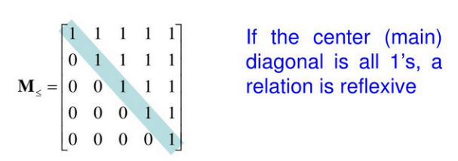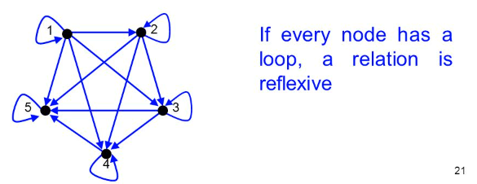

**irreflexive** if for all

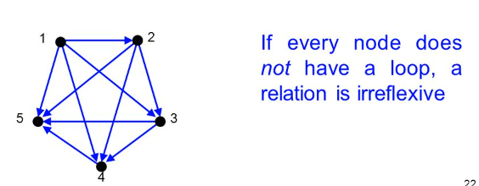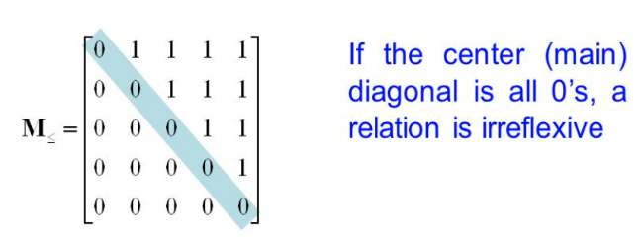

**symmetric**

if for all

*For all x and y, if x is related to y, y is related to x*

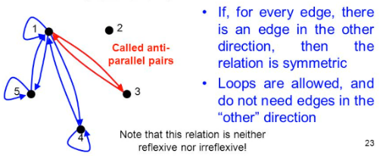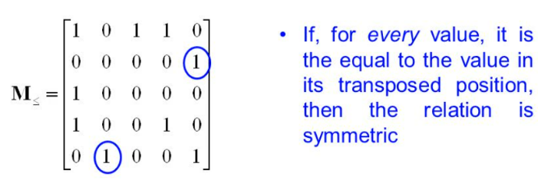

**asymmetric**

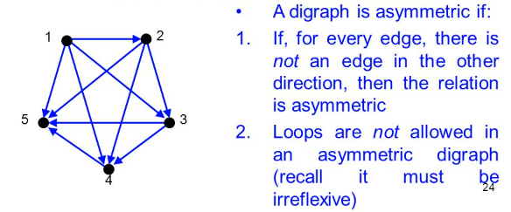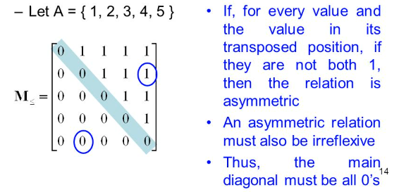

****transitive** if

for all

*For all x, y and z, if x is related to y and y is related to z, then x is related to z*

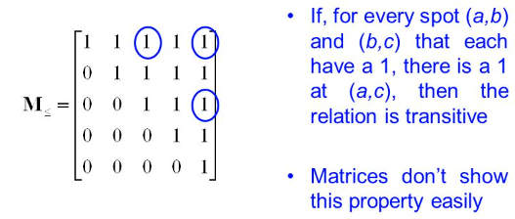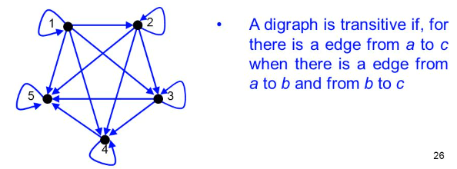

**antisymmetric** if for all

antisymmetry is not the opposite of symmetry

*repetition*

Example

The empty relation is the subset

It is clearly irreflexive, hence not reflexive

From COS2601

What is the difference between Λ and ?

Λ - **ϵ is a word**. represents the set that contains only the empty string {ε}

|{ϵ}|=1 *size of is one element*

– **is a language.** represents the empty set of strings ∅={}.

S = {} =

|∅|=0 *size of is zero elements*

Example: Which of the following relations are reflexive, symmetric,

antisymmetric, and/or transitive?

|  |  |  |  |  |
| --- | --- | --- | --- | --- |
|  | Reflexive | Symmetric | Antisymmetric | Transitive |
|  | • |  | • | • |
|  |  |  | • | • |
|  | • | • |  | • |
|  | • | • | • | • |
|  |  |  | • |  |
|  |  | • |  |  |

**Lesson 7**

Equivalence [S.R.T]

An equivalence relation on a set , is a relation on which is:

reflexive

symmetric

transitive.

An equivalence class is just a grouping of things that are equivalent to . For example, on set , would be a group of things that are equivalent to 1

Example:

Let *(x equivalent to y)* is divisible by 3, for any

Equivalence Class:

*Start with 2*

*2-5 = -3. This is divisible by 3*

*2-8 = -6. This is divisible by 3*

Equivalence Class:

*Start with 1*

*1-4 = -3. This is divisible by 3*

*1-7 = -6. This is divisible by 3*

Equivalence Class:

*Start with 3*

*3-6 = -3. This is divisible by 3*

*3-9 = -6. This is divisible by 3*

*Each pair consists of pairs where x-y is divisible by 3*

If you need to compute from a matrix draw its equivalent diagraph:

**Lesson 8**

Partial Order [A.R.T]

**Partial Order**

Poset: A Partial Order relation on a set , is a relation on which is

antisymmetric

*if two objects are both related*

*they are the same object*

reflexive

transitive.

**Total Order**

This is just a connected partial order

**Lesson 9**

Hasse diagrams

These are a good way to represent partial ordered set (poset). Remember, the for any is always a lattice

<https://www.assignmentexpert.com/homework-answers/mathematics/discrete-mathematics/question-117156>

Drawing a Hasse Diagram:

[1] Remove all self loops

[2] Remove all transitive edges

[3] Remove all directions on edges so that they are oriented upwards. So if , then appears above

Integer Divisors

Integer divisors (or factors) of a positive integer are the integers that evenly divide it

Example: Show the integer divisors of as a set and Hasse Diagram

**Wolframalpha**

Factors of 28

Hasse Diagrams quickly: <https://demonstrations.wolfram.com/HasseDiagramsOfIntegerDivisors/>

**Lesson 10**

Lattices

-

*A poset (partially ordered set)*

-

*For every pair that belongs to the partial order*

*-*

*is represented as (OR) join of a and b*

*is represented as (AND) meet of a and b*

*and are binary operations on*

A complimented lattice is a bounded lattice in which every element has a compliment

Example: is the poset a lattice?

[1] Find the upper and lower bounds for each pair

*meet*  *join*

*meet*  *join*

…

Therefore, is a lattice

Example: is the poset a lattice?

[1] Find the upper and lower bounds for each pair

*meet*  *join*

*meet*  *join*

…

Therefore, is a lattice

Example: is the poset a lattice?

is also called the powerset or Boolean algebra

Boolean algebras are a special case of orthocomplemented lattices

*is the powerset over the subset*

*Remember that the power set (or powerset) of any set is the set of all subsets of , including the empty set and itself.*

Therefore, is a lattice

Example: Hasse Diagrams that do not represent lattices

c) or does not exist

f) or does not exist

or does not exist

g) or does not exist

**Lesson 11**

Big O

<https://web.mit.edu/16.070/www/lecture/big_o.pdf>

For the formal definition, suppose and are two functions defined on some subset of the real numbers. We write

(or for to be more precise) if and only if there exist constants N and C such that

for all .

Intuitively, this means that does not grow faster than .

Example: ASS2 Q4

<https://math.stackexchange.com/questions/3101678/prove-or-disprove-n2-logn-on2>

*Let and*

*show that*

Suppose is

Then there exists and such that:

for all

Now

But we know is not a bound function (of the form )

**Lesson 11**

Cycle Notation of Permutations

<https://www.youtube.com/watch?v=MpKG6FmcIHk>

Remember that a permutation is a rearrangement.

Permutations of things:

Example: Let’s try permutation as a function

inputs

outputs

Example: Let’s try composition (Time consuming)

Plug in each of the five numbers into the composition function:

Example: Let’s try cycle notation

[1] Write down your inputs

[2] Pick the first number not scratched out. Let’s chose

Therefore, maps to in our function

[3] Remove the numbers in our mapping

[4] Map the next number

maps to

maps to

[5] We have our first cycle:

*This is called a 3-Cycle*

[6] Repeat 2 - 5

*This is called a 2-Cycle or a transposition*

**Therefore the permutation can be written as a product of two cycles**:

Example: Let’s try cycle notation again

or

Remember that a cycle can be rotated:

Example: Let . Compute

**Wolframalpha**

permutation (4 1 3 5)(2)(6)

**Wolframalpha**

permutation (5 6 3)(1)(2)(4)

Therefore:

**Wolframalpha**

permutation (4 1 3 5)(5 6 3)(2)

*Manual. Go from right to left. Compute values in a cycle. If the value is not present, go to the next available cycle*

Remaining

and:

**Wolframalpha**

permutation (5 6 3)(4 1 3 5)(2)

*Manually*

*remaining number*

Therefore, neither product is a cycle

Example: SEM1 ASS2 Q6 a

Let . Compute

**Wolframalpha**

permutation (2 3)(1)(4)(5)(6)(7)(8)

**Wolframalpha**

permutation (4 5 6)(1)(2)(3)(7)(8)

**Wolframalpha**

permutation (1 4 5 7)(2)(3)(6)(8)

Therefore:

*Order starting with the cycle that has the lowest number (1 4 5 7)*

**Wolframalpha**

permutation (1 4 5 7)(2 3)(4 5 6)(8)

*Manual. Go from right to left. Compute values in a cycle. If the value is not present, go to the next available cycle*

Remainder

Example: SEM1 ASS2 Q6 b

Let . Compute

Therefore:

*Order starting with the cycle that has the lowest number (1 2)*

**Wolframalpha**

permutation (1 4 5 7)(2 3)(4 5 6)(8)